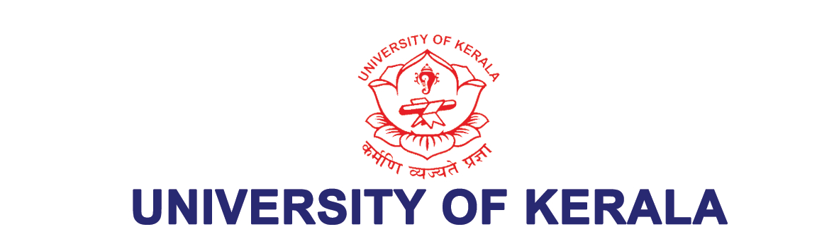

Re-accredited by NAAC with A++ Grade (2022), Ranked 24th Among Indian Universities - NIRF 2023
KERALA UNIVERSITY BUSINESS INNOVATION & INCUBATION CENTRE (KUBIIC)
Kariavattom Campus, Thiruvananthapuram, Kerala, Pin – 695 581
Dr. Shiburaj S.  Director, KUBIIC | Email: drshiburaj@keralauniversity.ac.in  kubiic@keralauniversity.ac.in  Mob: 9495826669

No. KUBIIC/DR/006/2025 20.01.2025

Quotation Notice

Kerala University Business Innovation & Incubation Centre, University of Kerala, Karyavattom Campus has invited sealed quotations for the below-mentioned items. Those who are interested please send the Quotation to the Director, KUBIIC, Department of Computational Biology & Bioinformatics, University of Kerala, Karyavattom Campus, Thiruvananthapuram - 695581 by Speed post/Courier, so as to reach here before the due date and super-Scribe the cover with “Quotation for Desktop High End Windows Pro (Intel Processor) & UPS”. Our standard commercial terms are given herewith. You may kindly give your terms & conditions in detail.

Sl No | Description | No.
1 | Desktop High End Windows Pro (Intel Processor)  Processor: Intel Core i5 12400 @ 2.5 GHz base frequency, 6 crore, 18 MB cache, TDP 65 W  Chipset: Compatible Chipset  Motherboard: OEM Motherboard  Memory: 16GB DDR4 RAM upgradable to 32 GB  Hard Disk Drive: 512 GB SSD  Graphics Adapter: High end Graphics adapter with 2.0GB memory  Monitor: 21.5” or larger TFT/LED Digital Colour Full HD Monitor. Same make as PC  Keyboard: USB interface keyboard same make as PC  Mouse: Optical with USB interface. Same make as PC  Ports: 6 USB Ports or more (at least 2 USB 3.0 ports and two ports in front panel (at least 1 should be USB 3.0))  Networking facility: 10/100/1000 on board integrated Network Port & Wi-Fi 802.11 b/g/n connectivity  Certifications: EPEAT Certificate/EPR certificate and ROHS Compliance  Warranty: 5-year comprehensive on-site warranty including Monitor, Mouse & Keyboard  Operating System: Windows 11 Pro | 1

2 | UPS for Desktop Computer  Capacity: 600VA  Battery details: 12V, 7Ah-1 No  Battery Warranty: 1 Year  Product Warranty: 2 Years  Preferred Brands: V Guard, APC, Hykon, Numeric | 1

Commercial Terms
 | Validity | Your offer should be valid for a period of at least three months.
 | Delivery | You may confirm the earliest delivery schedule in your reply.
 | Price | Your prices should be firm.
 | Taxes & duties | You may confirm the current taxes and duties and include the same in your price.
 | Payment Terms | Payment will only be made after the item has been satisfactorily installed and is in good working condition.
 | Complaint | Complaints with the items supplied should be rectified/replaced to the satisfaction of the University by the suppliers at their own cost.
The last date of receipt of quotations is 05.02.2025 at 2.30 PM. The quotation will be opened at 3.00 PM on the same day in the presence of vendors then present

Yours faithfully,


Director-KUBIIC

